
DIOCESAN MEMBER
APPLICATION FORM (Please use capital letters)
TITLE. ____________________________
NAME ______________________________________________
ADDRESS _____________________________________________
______________________________________________
POST CODE _____________________ TEL NO _______________
EMAIL ADDRESS _______________________________________
DATE OF BIRTH ____________________________
PREVIOUS BRANCH (If applicable) _____________________________
WHEN DID YOU JOIN MOTHERS’ UNION (approximation) ____________________
DO YOU LIVE ALONE YES/NO ARE YOU HOUSEBOUND YES/NO
As a DIOCESAN MEMBER we will keep in touch with you preferable via email. NEWSLINE will be delivered by someone from your Deanery, or it may be posted to you. PRAYER DIARY AND CONNECTED will come by post directly from MSH. If your Details Change please let us know ASAP.
WE HOPE YOU WILL FEEL VALUED AND CONTINUE AS A FULLY PAID-UP MEMBER OF OUR WONDERFUL ORGANISATION.
ANNUAL SUBSCRIPTIONS should be paid by Bank Transfer or by cheque direct to the Diocesan Treasurer
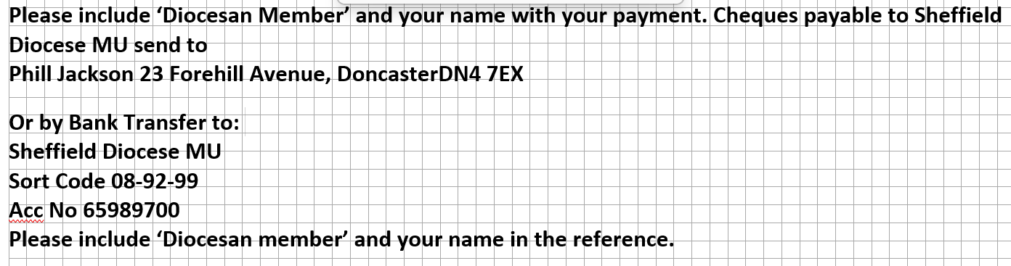
ARE YOU ELIGIBLE TO PAY GIFT AID (this will help Mothers’ Union at no cost to you) YES/NO
SIGNED____________________________ DATE _________________
Please Return to:
Elizabeth Dean (Data &Media Coordinator) 177 Allerburn Lea, Alnwick NE66 2QR or scan/photo and email to data@sheffieldmu.co.uk TEL: 07702735744

